Overview:

* Increase in amount of losses especially among the left flank
* 7% Increase in defensive duel win rate
* 10% decrease in offensive duel win rate
  + Keenai and Evan only had 1 missed duel each
* 4% decrease in forward pass accuracy
* Most offensive duels and passes were down the left flank
* Increase in UCSD deep completed passes to 7
* Opponent increased deep completed passes to 16
* Higher average pass length
* Crossing accuracy of 33% goal is 38%
  + Cole had an accuracy of 75%
* Majority of shots originated from set pieces, tackles, or throw ins
* Majority of shots were assisted from cutbacks/crosses

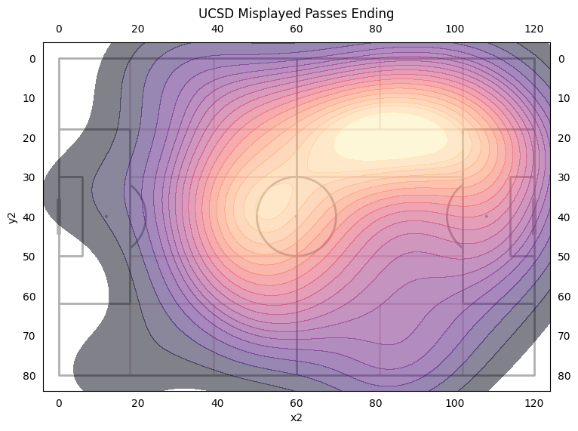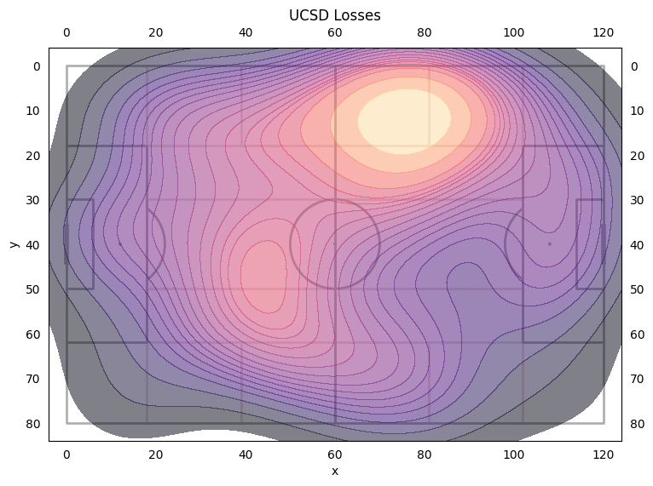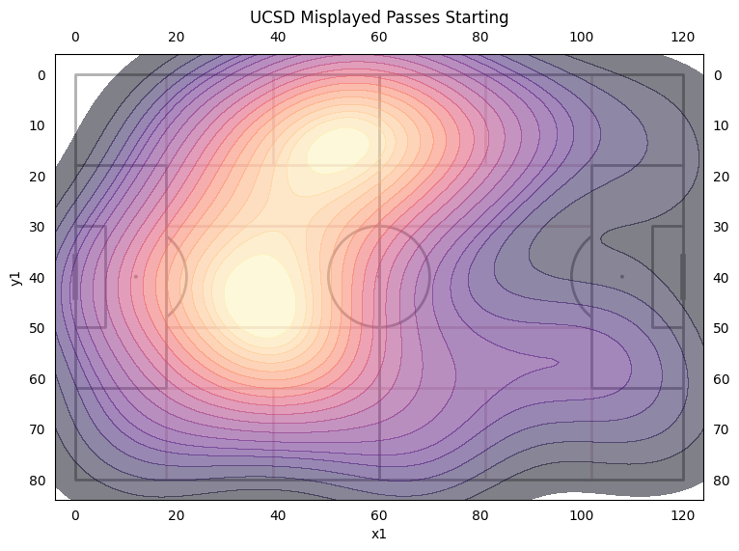

* UCSD had 131 Losses against Duke. Last year’s average was 118.2
* Majority of Losses and Misplaced passes were on UCSD’s left flank.
* Player the most losses was Max with 19 losses, then Brian with 15, then Jonah with 13, then Carter with 12.

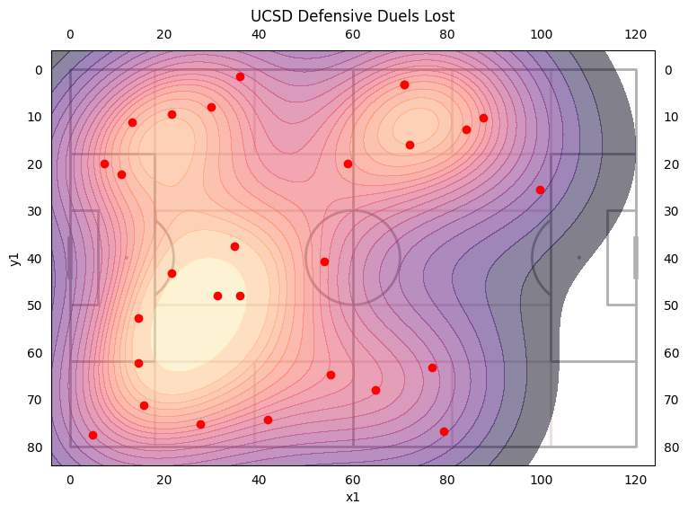

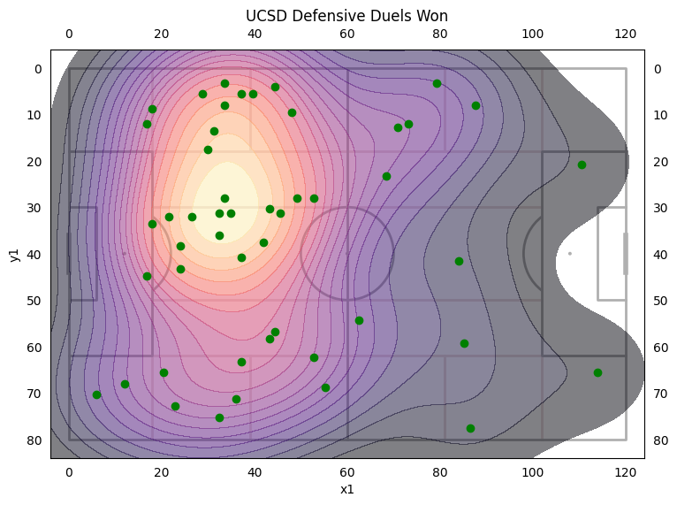

Defensive Duels:

* Lot of defensive duels won on the left side
* Majority of defensive duels lost on the right side.
* Won 65% of our defensive duels an increase from last year’s average of 58.9%
* Keenai had a defensive duels win rate of 90% with 9 won, Evan had a defensive duels win rate of 86% with 7 won.

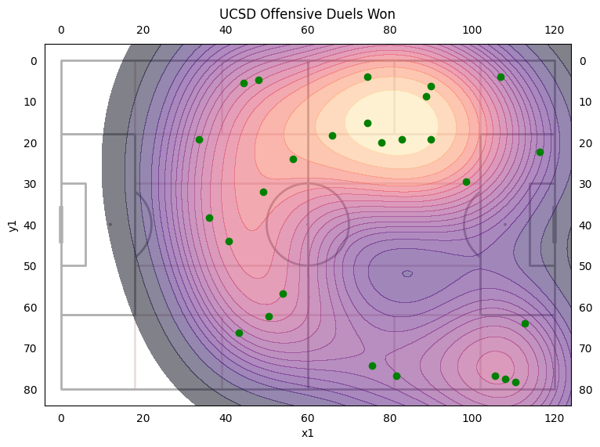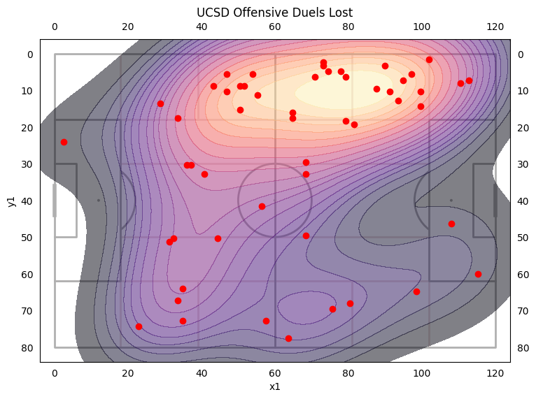

Offensive Duels:

* Most of the offensive duels are on UCSD’s left flank
* Won 30.1% of our offensive duels a decrease from last year’s 39.6%
* McGee had the most offensive duels at 14 and won 43%, Brian had 12 and won 25%, Max had 11 and won 27%, Cole had 7 and won 19%

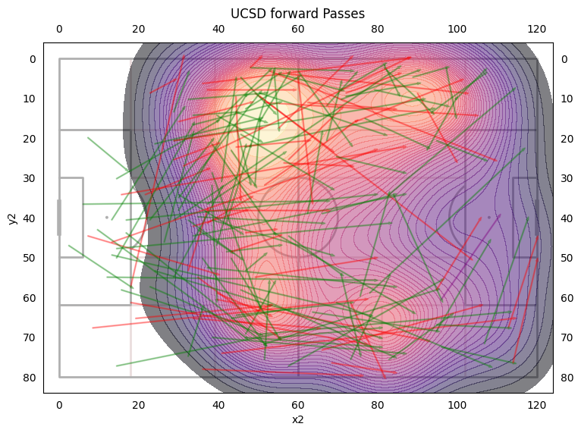

* UCSD had 7 Deep completed passes
* Duke had 16 Deep Completed passes
* All goals came off of Deep Completed passes
* UCSD had a forward pass accuracy of 62.5%, a decrease of 4% from Santa Clara.
* UCSD had 112 Forward passes a decrease from Santa Clara (133) and last year (134)
* Average Pass Length of 23.26 against Duke which is an increase from 21.88 last year and Santa Clara 21.09
* Increase in accuracy passing into attacking third from 59.5% to 65.5%
* Most of our attacking passes were focused on the left flank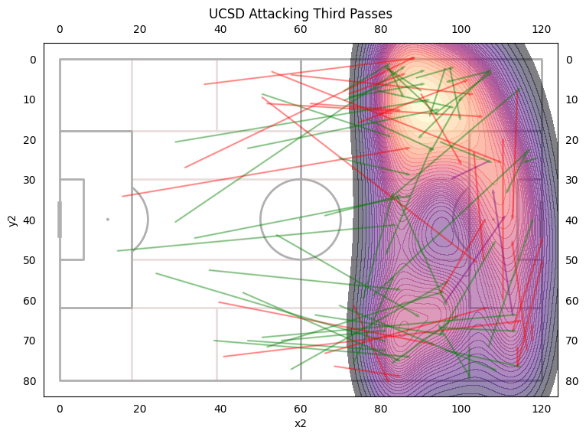

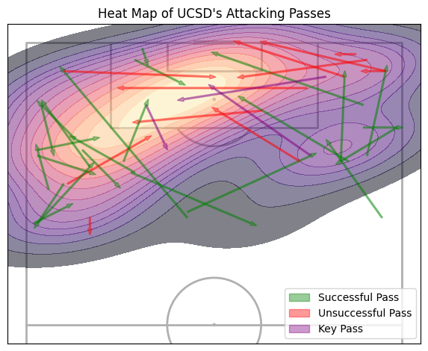

Crosses

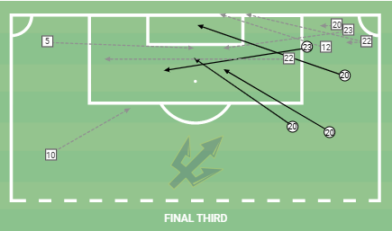

* Crossing accuracy of 33% - Last year’s was 36% and our goal is 38%
* Cole(#20) had a crossing accuracy of 75%
* Most crosses came from the right side.

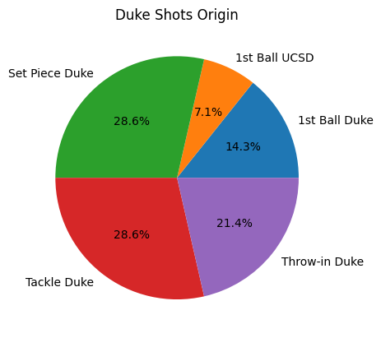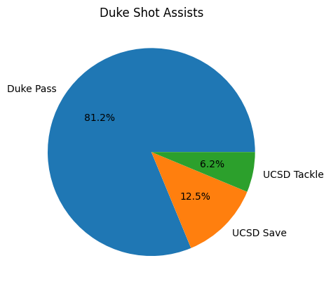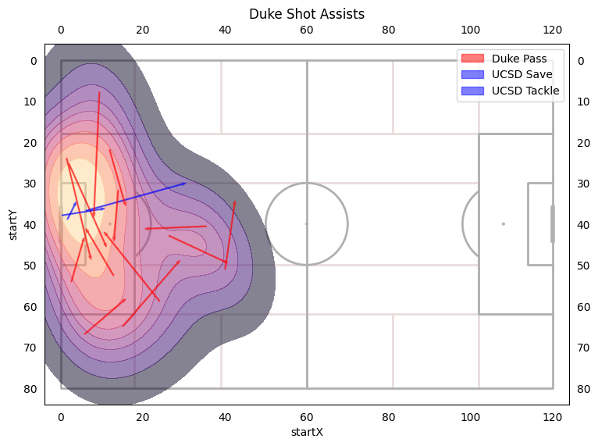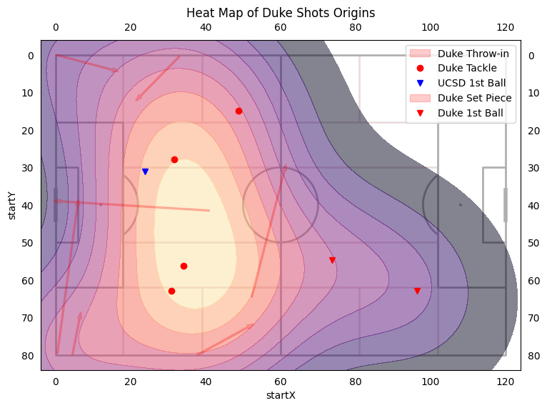

* Majority of the chances are off setpieces and tackles
* Majority of shot assists are cutbacks/balls across the box
* UCSD had 18 shots against which is an increase from last year’s average 11.4 and Santa Clara 14
* Duke had xG of 4.56 but only scored 3